Vision Document

**Software Design & Architecture**

Course Instructor  
**Sir Khubaib Amjad**

Submitted By

**Waqas Shahid(22i-2469)**  
**Abdul Raffay(22i-2546)  
Kaif Anwar(22i-2668)**

Section  
**E**

Date

**Sunday, April 14, 2024**

Spring 2024



**Department of Computer Science**

FAST – National University of Computer & Emerging Sciences

Table of Contents

1 Document Version 5

2 System Sequence Diagrams 6

2.1 UC-025: Campus News and Achievements 7

2.2 UC-012: Study Groups and Project Collaboration 7

2.3 UC-013: Marketplace 8

2.4 UC-014: Event Planning and Organization 9

2.5 UC-015: Campus Services 10

2.6 UC-002: Voice Controlled Navigation and Interaction 11

2.7 UC-010: E-Learning Spaces 13

2.8 UC-018: Access Peer Tutoring and Academic Support 14

2.9 UC-019: Receive Academic and Career Guidance 15

2.10 UC-021: Class Schedule Integration and Study Reminders 16

2.11 UC-023: Skill Sharing and Workshop Platform 17

2.12 UC-028: Carpooling and Ride-Shared Board 18

2.13 UC-030: Personalized Academic and Career Advising 19

2.14 UC-026: Mental Health and Wellness Support 20

2.15 UC-001: Augmented Reality Filters and Spaces 21

2.16 UC-003: Project Collaboration Spaces 22

2.17 UC-004: Local Community Engagement 23

2.18 UC-007: Fully Customizable UI 24

2.19 UC-008: Community-Driven Moderation 25

2.20 UC-024: Sustainability Initiatives 26

2.21 UC-027: Virtual Campus Tours 27

2.22 UC-029: Gamification and Rewards 28

2.23 UC-031: Language Exchange and Cultural Exchange Forums 29

2.24 UC-034: Personal Safety and Campus Security Features 30

2.25 UC-037: Digital Student ID and Wallet 31

2.26 UC-038: Student-Led Content and Publication Platform 32

2.27 UC-039: Mentorship Program Matching 33

3 Sequence Diagrams 34

3.1 SDs for UC-011 34

CreatePost() 34

PostNews() 35

selectGroup() 35

3.2 SDs for UC-013 36

InitatePurchase() 36

navigateMarketplace() 37

3.3 SDs for UC-012 37

InitiateGroup() 37

SelectGroup() 38

3.4 SDs for UC-014 39

CreateEvent() 39

RequestEventCancellation() 39

3.5 SDs for UC-015 40

AccessCourseContent() 40

SelectServiceType() 41

3.6 SDs for UC-002 42

LikePost() 42

NavigateToEvents() 42

3.7 SDs for UC-010 43

EnrollInCourseAndAccess() 43

SelectElearningSpaces() 44

3.8 SD for UC-003 45

MonitorAndProvideSupport() 45

3.9 SDs for UC-023 46

signUpForWorkshop() 46

3.10 SDs for UC-024 47

setDeadlineReminder() 47

3.11 SDs for UC-021 47

sendReminder() 48

3.12 SDs for UC-023 48

registerWorkshop() 48

provideWorkshopDetails() 50

3.13 SDs for UC-018 51

seekAssistance() 51

validateRequest() 53

ScheduleSession() 54

3.14 SDs for UC-019 55

provideGuidanceAndSupport() 55

accessAdvisingSectionn() 55

GenerateAndSelectRecommendations() 56

3.15 SDs for UC-030 57

accessPersonalAcademicAndCareer() 57

ProvideAcademicAndCareerInfo() 57

3.16 SDs for UC-041 58

displayProgress() 58

3.16 SDs for UC-008 59

createStudyGroup() 60

3.17 SDs for UC-037 62

purchaseFromMarket() 62

3.18 SDs for UC-034 64

createEvent() 64

4 Class Diagram 65

Class Diagram: Lucidchart 65

5 Domain Model 66

6 Work Division 66

# 1 Document Version

|  |  |  |  |
| --- | --- | --- | --- |
| **Version** | **Date** | **Description** | **Authors** |
| V1.0 | 2/21/2024 | Initial Vision Document | Waqas, Abdul Raffay & Kaif Anwar |
| V2.0 | 2/22/2024 | Refined Vision Document | Waqas |
| V3.0 | 13/03/2024 | Use Case Diagram, Domain Model and Fully Dressed Use Cases | Waqas, Abdul Raffay & Kaif Anwar |
| V4.0 | 14/04/2024 | System Sequence Diagrams, Sequence Diagrams, Class Diagram, GRASP | Waqas, Abdul Raffay & Kaif Anwar |

# 2 System Sequence Diagrams

## 2.1 UC-025: Campus News and Achievements

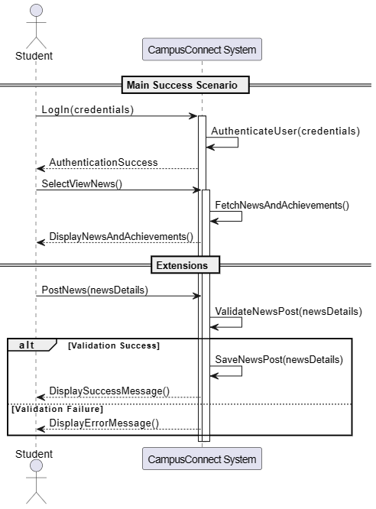

## 2.2 UC-012: Study Groups and Project Collaboration

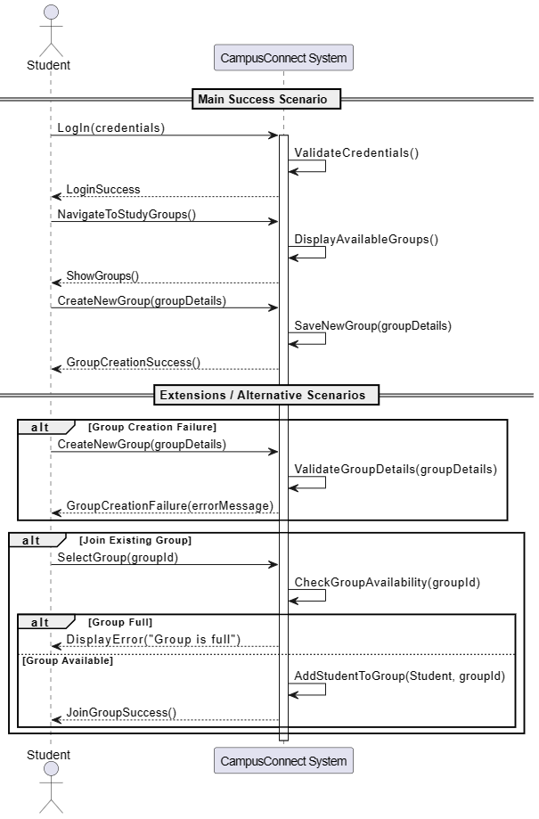

## 2.3 UC-013: Marketplace

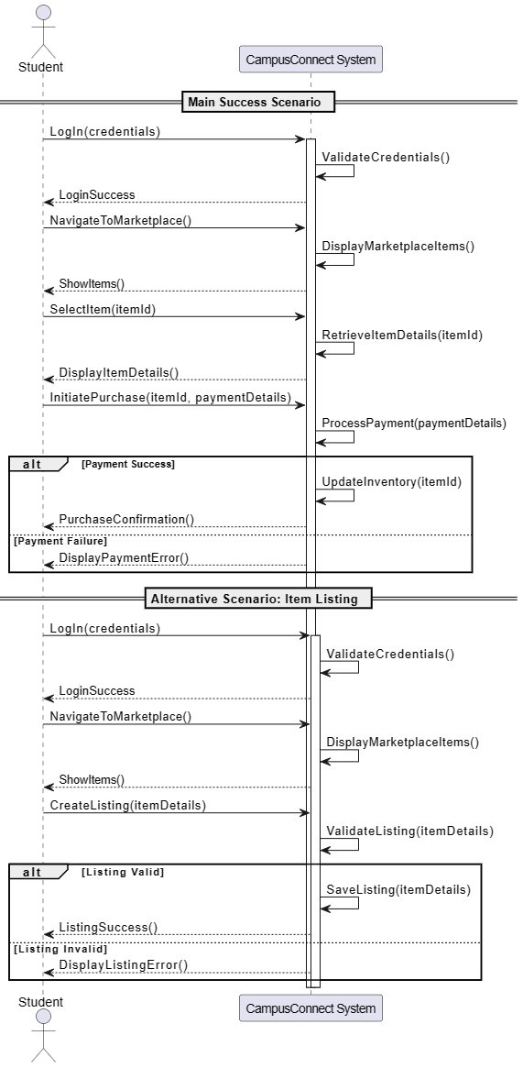

## 2.4 UC-014: Event Planning and Organization

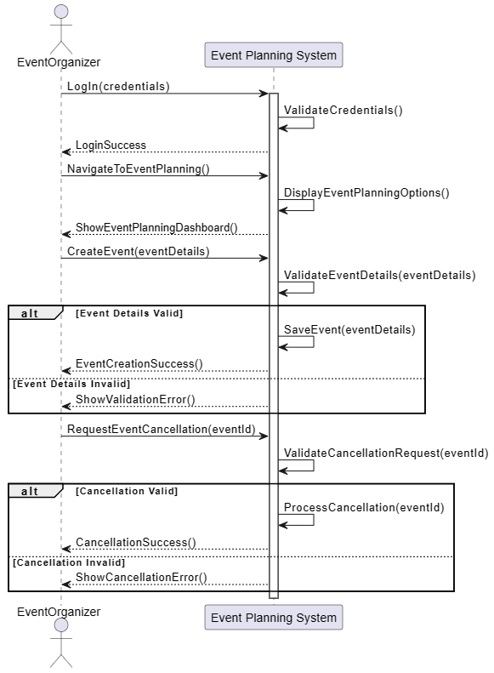

## 2.5 UC-015: Campus Services

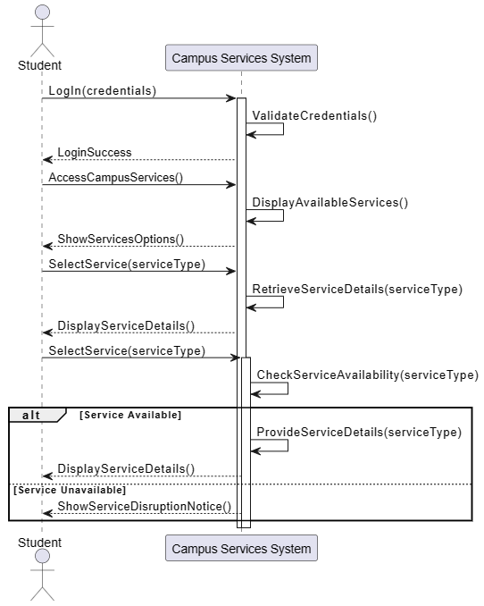

## 2.6 UC-002: Voice Controlled Navigation and Interaction

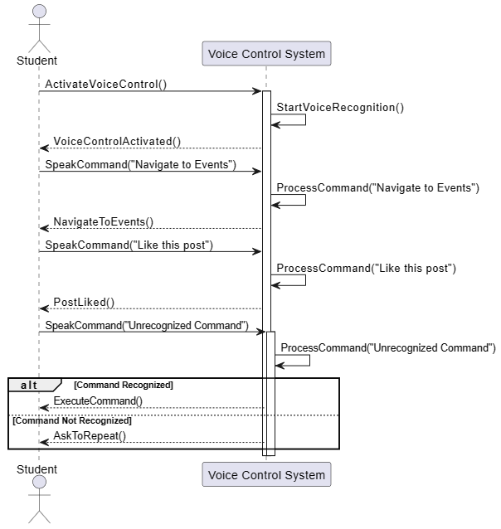

## 2.7 UC-010: E-Learning Spaces

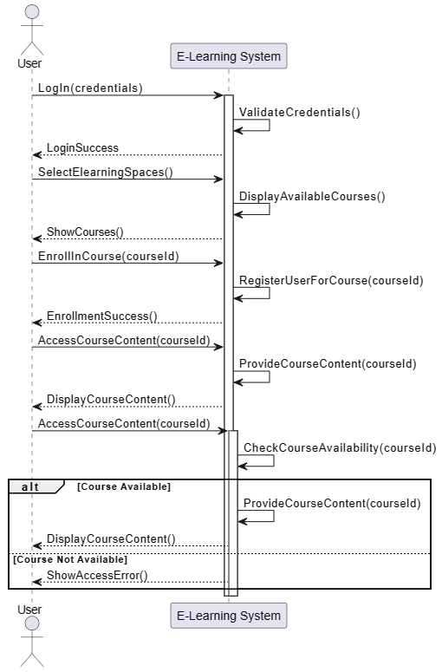

## 2.8 UC-018: Access Peer Tutoring and Academic Support

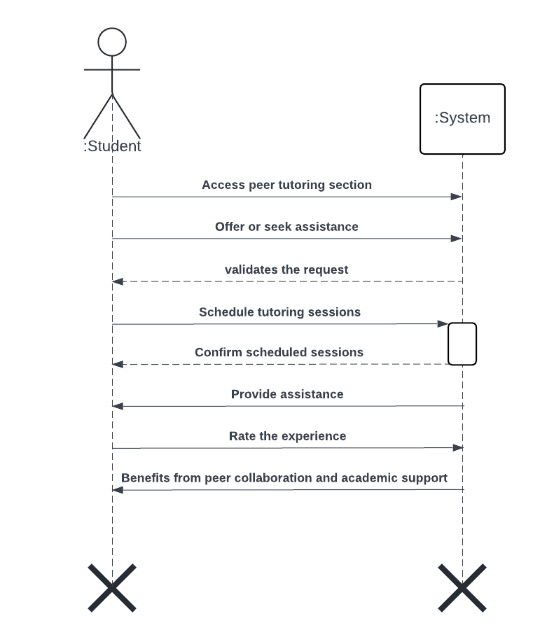

## 2.9 UC-019: Receive Academic and Career Guidance

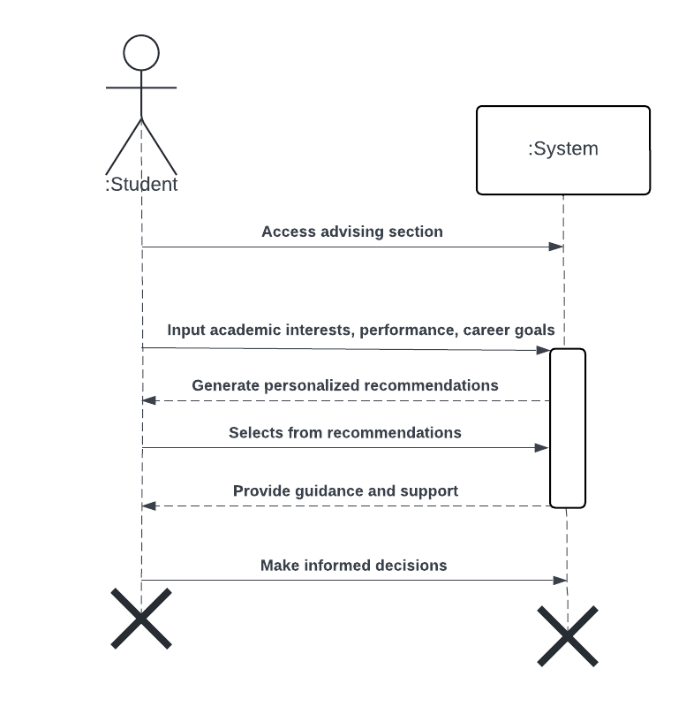

## 2.10 UC-021: Class Schedule Integration and Study Reminders

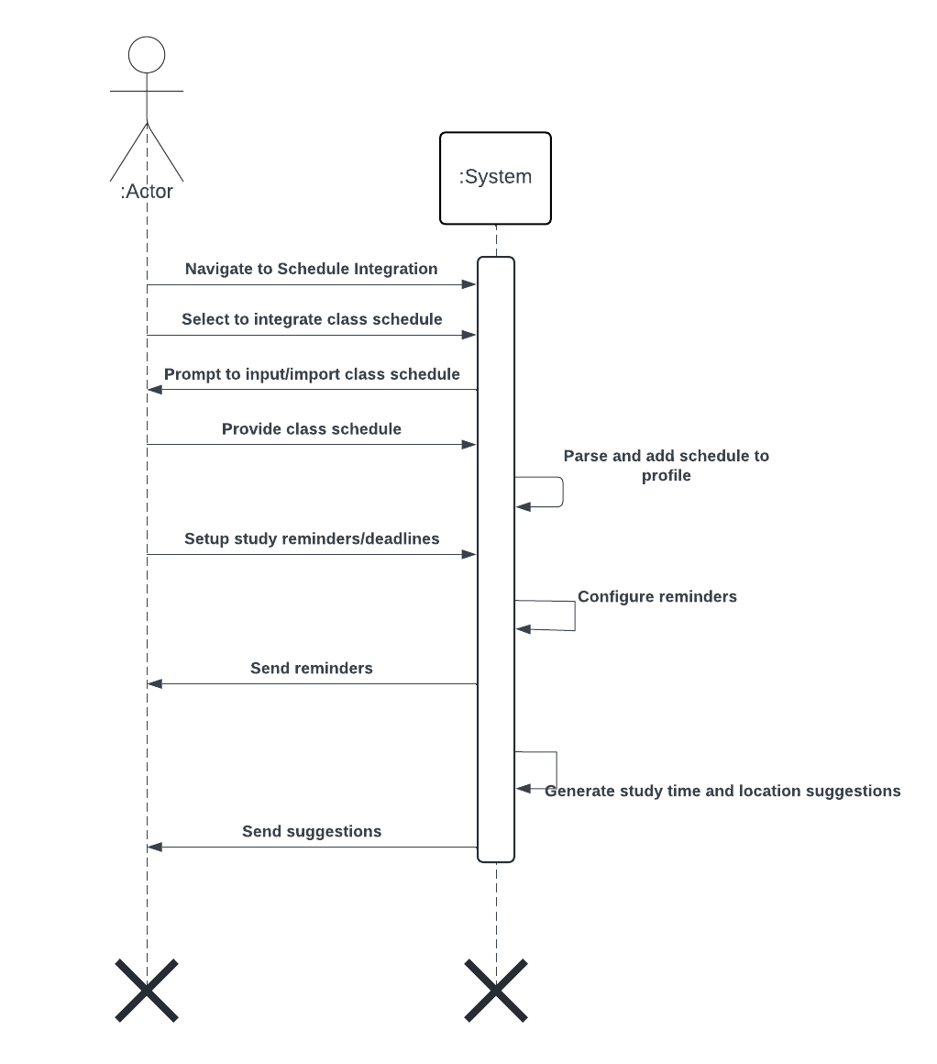

## 2.11 UC-023: Skill Sharing and Workshop Platform

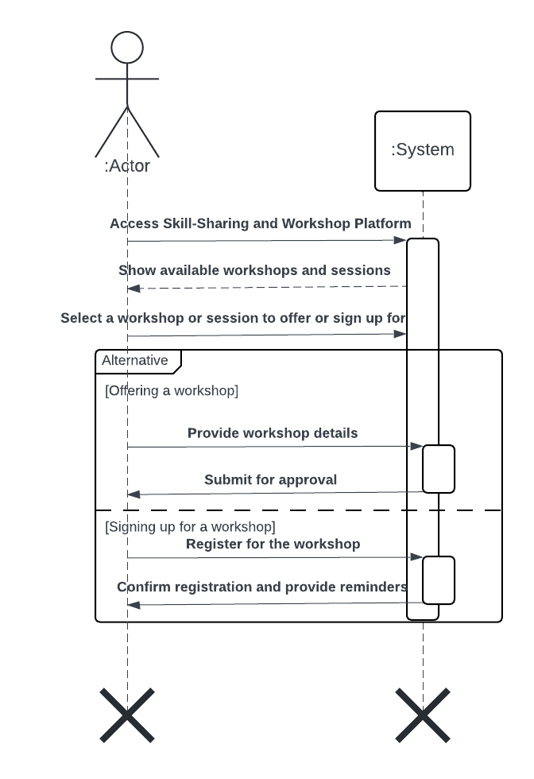

## 2.12 UC-028: Carpooling and Ride-Shared Board

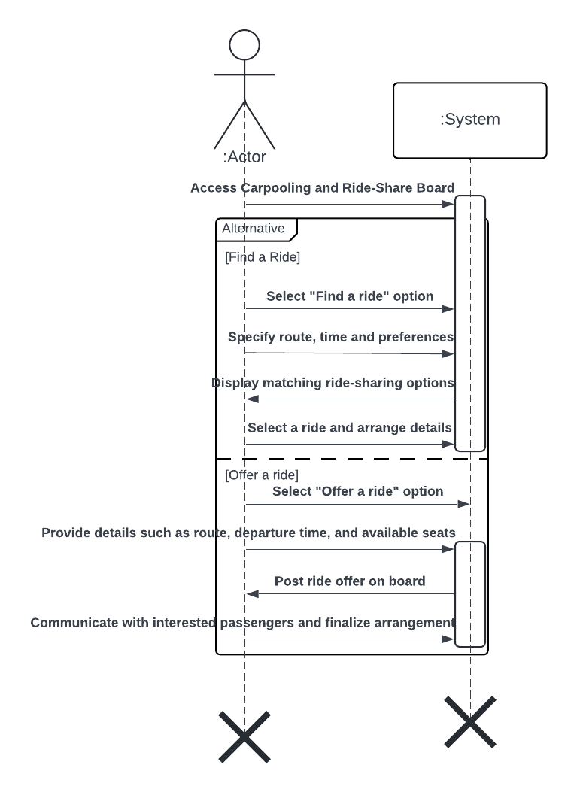

## 2.13 UC-030: Personalized Academic and Career Advising

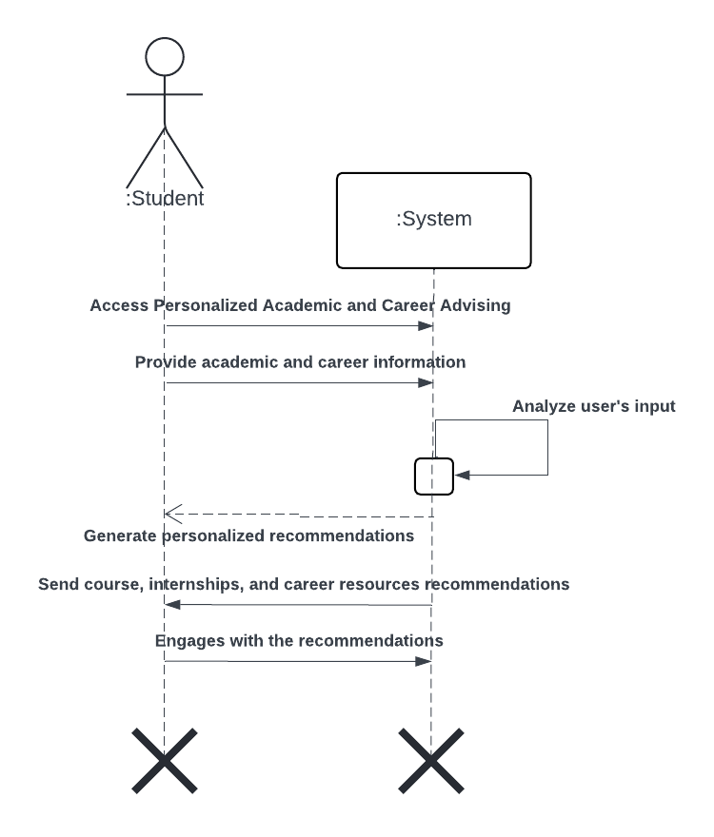

## 2.14 UC-026: Mental Health and Wellness Support

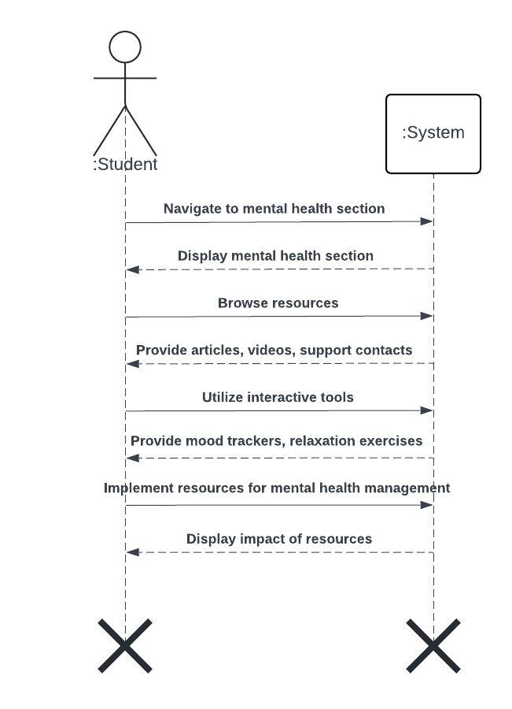

## 2.15 UC-001: Augmented Reality Filters and Spaces

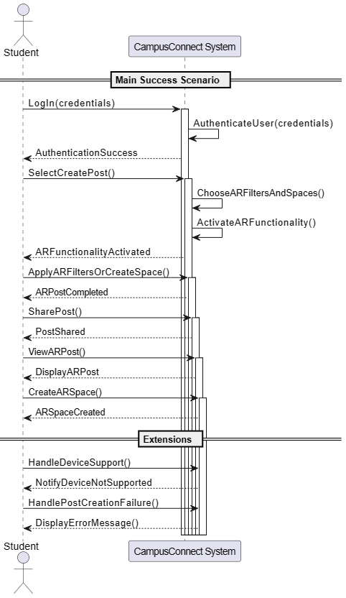

## 2.16 UC-003: Project Collaboration Spaces

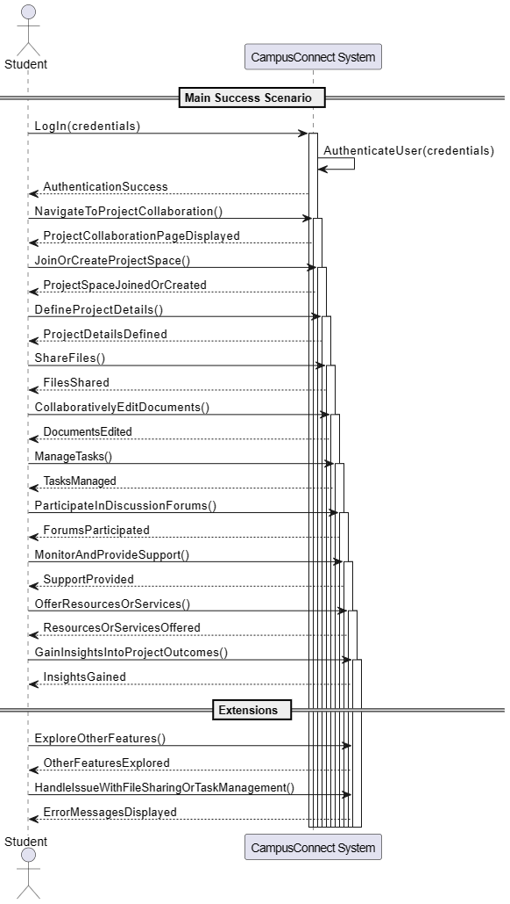

## 2.17 UC-004: Local Community Engagement

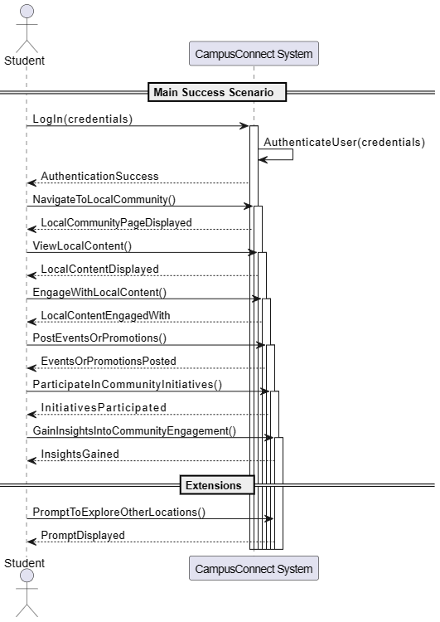

## 2.18 UC-007: Fully Customizable UI

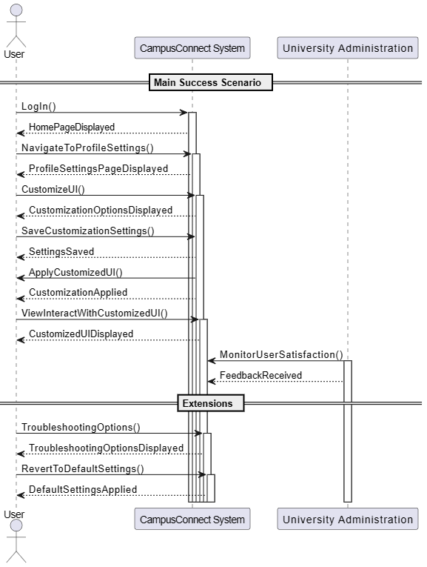

## 2.19 UC-008: Community-Driven Moderation

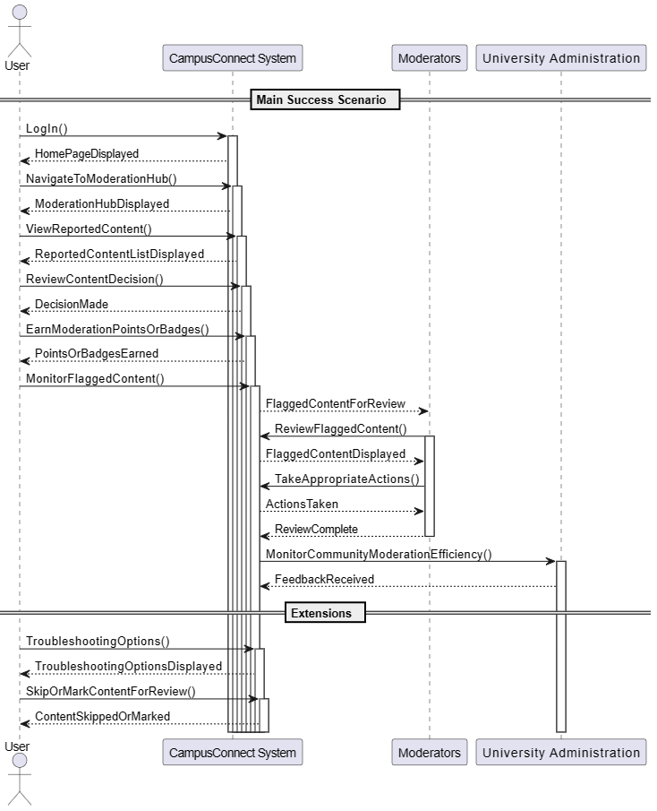

## 2.20 UC-024: Sustainability Initiatives

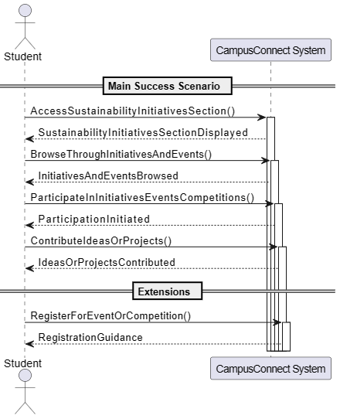

## 2.21 UC-027: Virtual Campus Tours

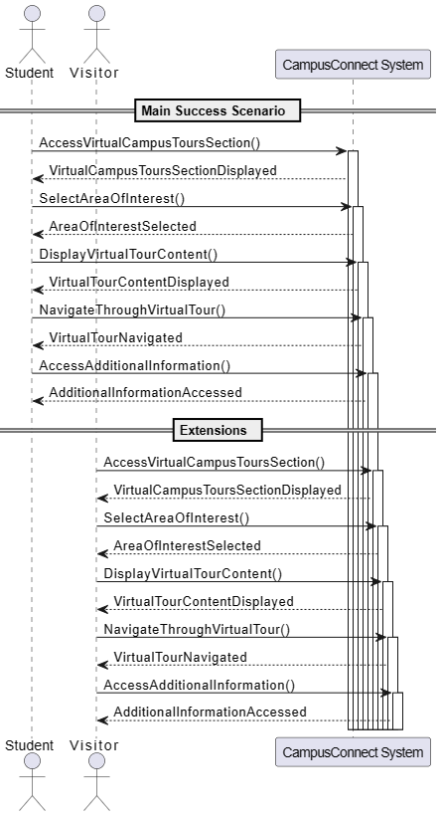

## 2.22 UC-029: Gamification and Rewards

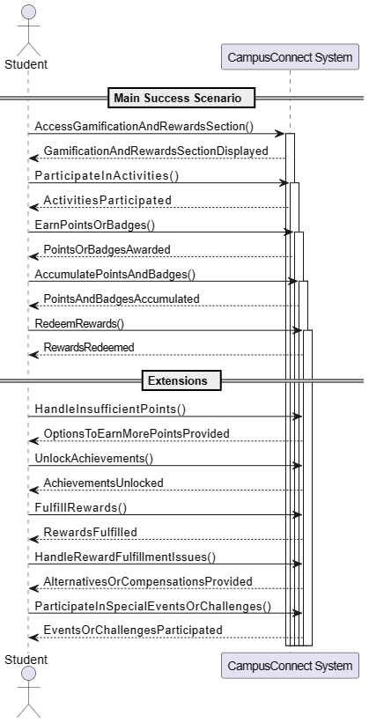

## 2.23 UC-031: Language Exchange and Cultural Exchange Forums

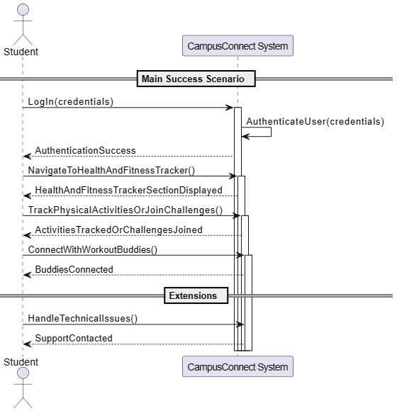

## 2.24 UC-034: Personal Safety and Campus Security Features

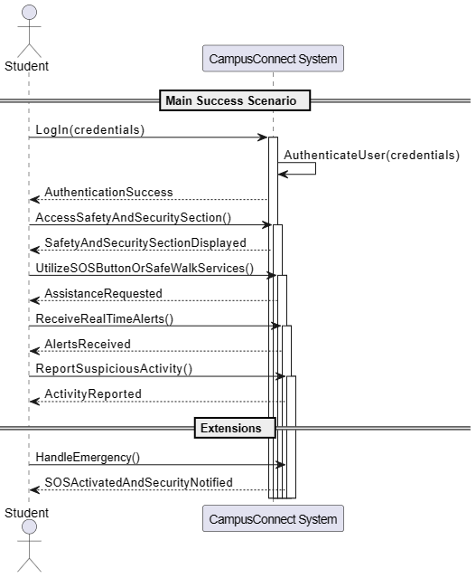

## 2.25 UC-037: Digital Student ID and Wallet

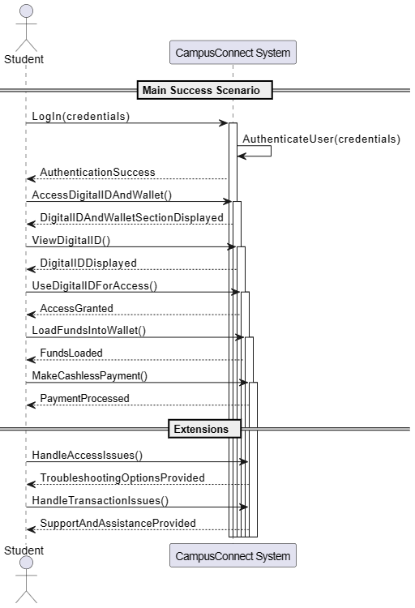

## 2.26 UC-038: Student-Led Content and Publication Platform

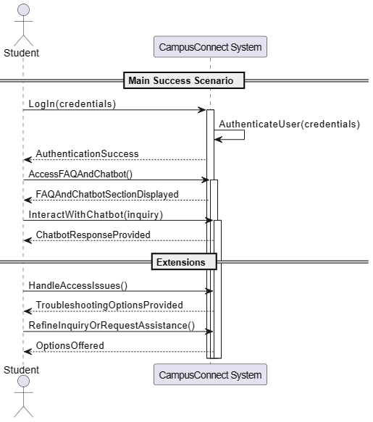

## 2.27 UC-039: Mentorship Program Matching

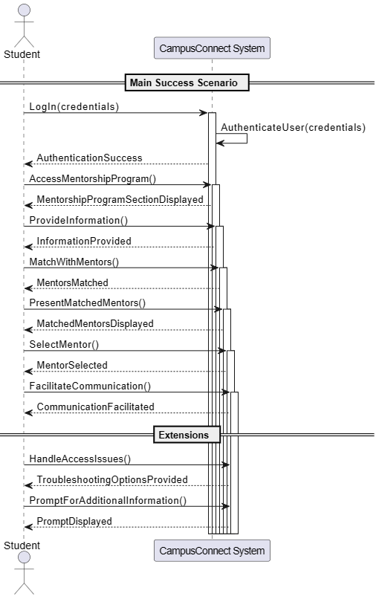

# 3 Sequence Diagrams

# 3.1 SDs for UC-011

## CreatePost()

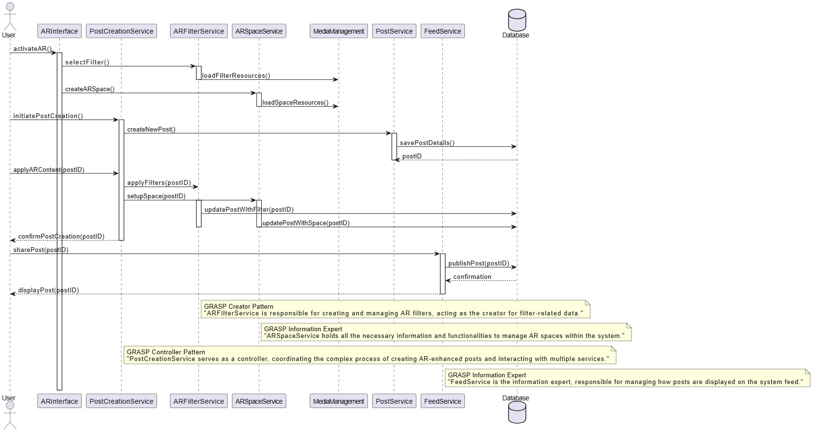

## PostNews()

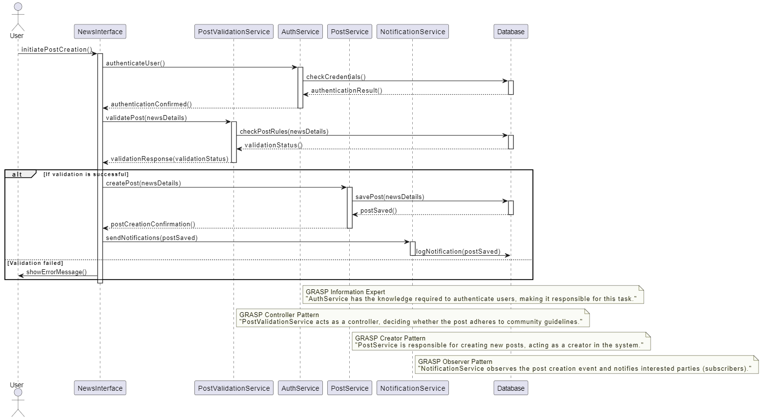

## selectGroup()

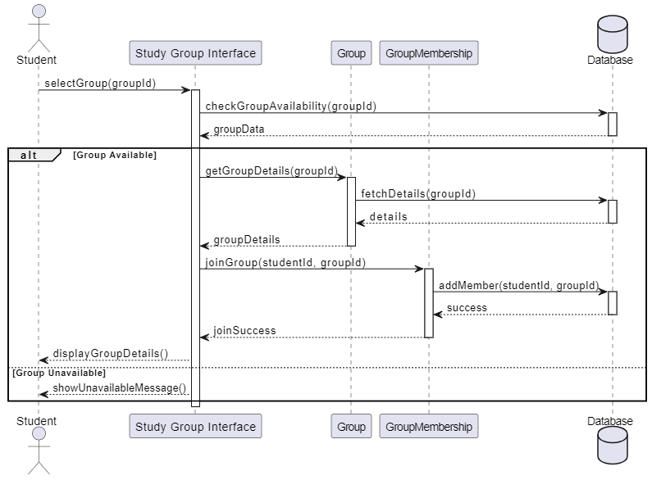

# 3.2 SDs for UC-013

## InitatePurchase()

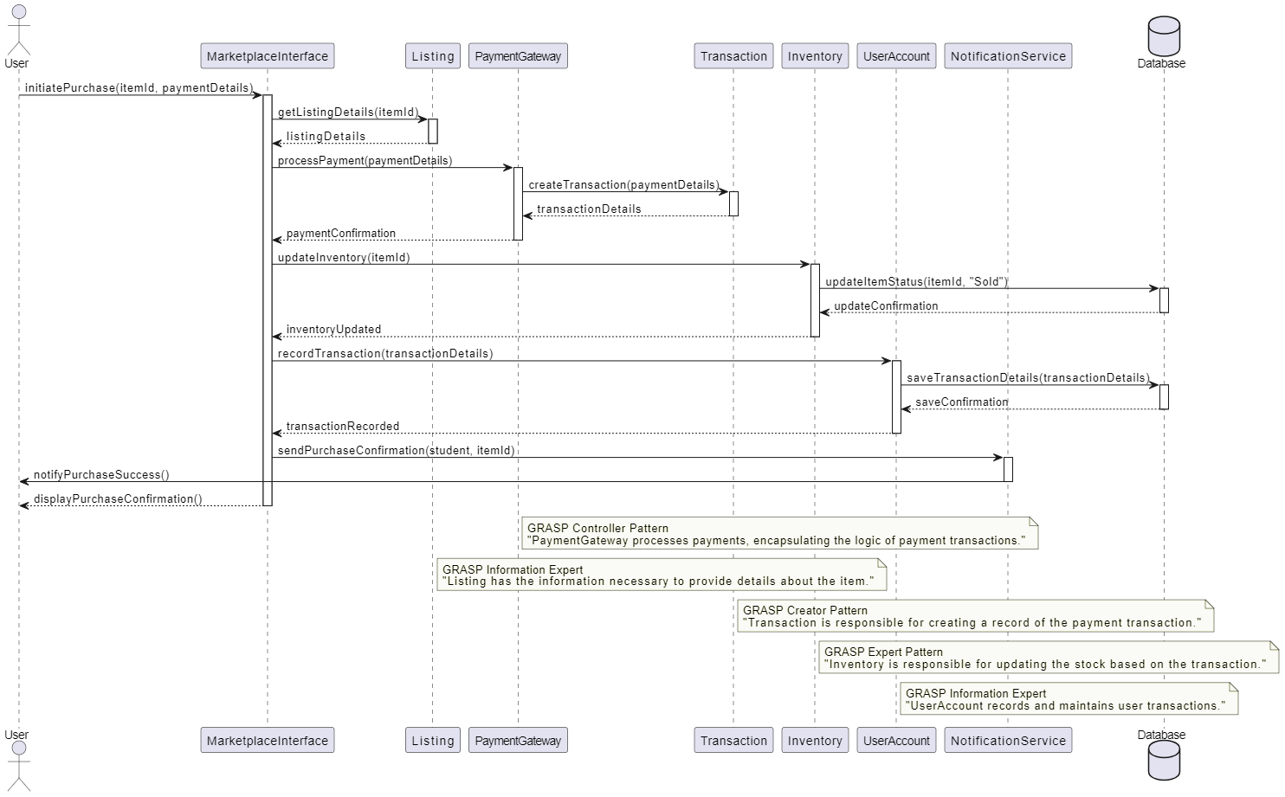

## navigateMarketplace()

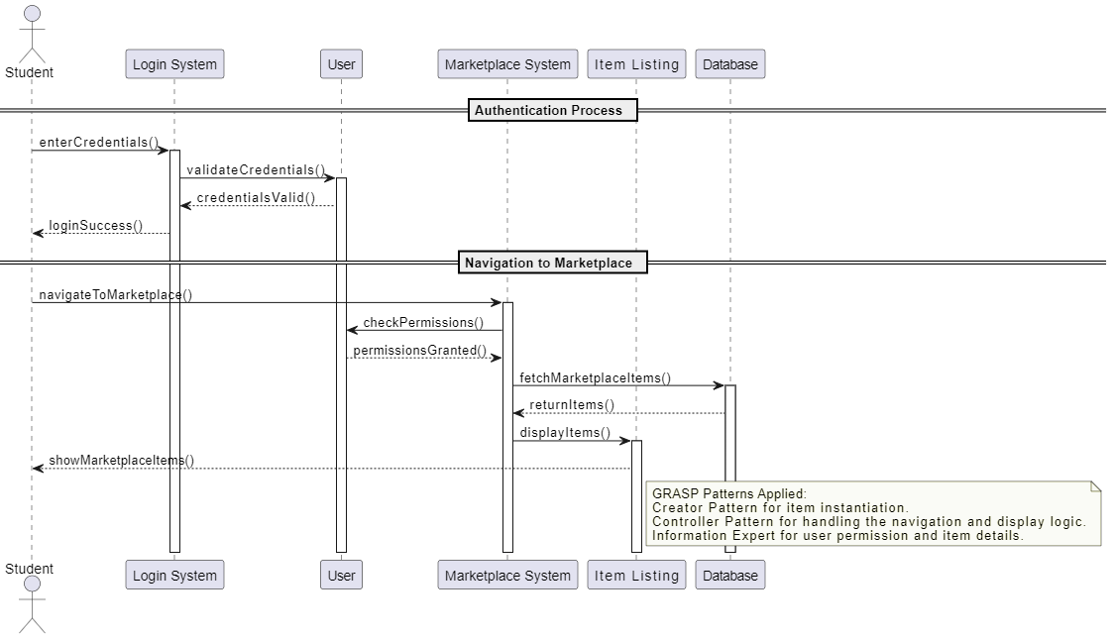

# 3.3 SDs for UC-012

## InitiateGroup()

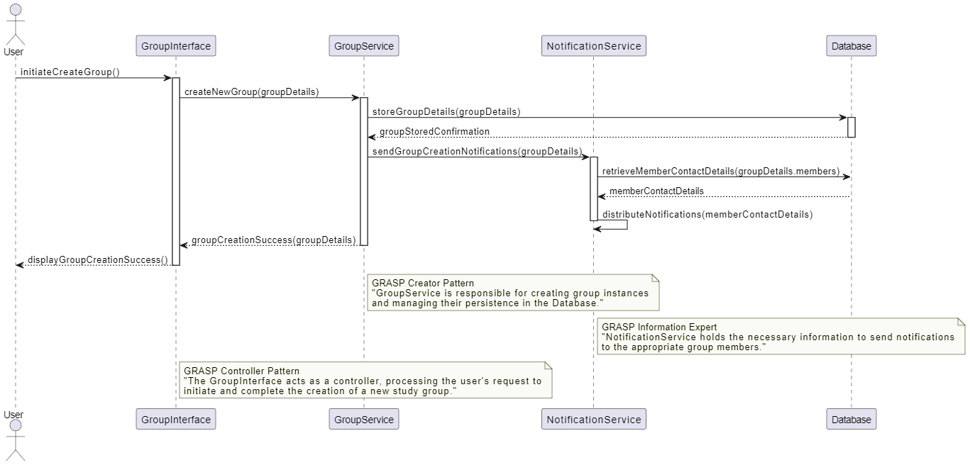

## SelectGroup()

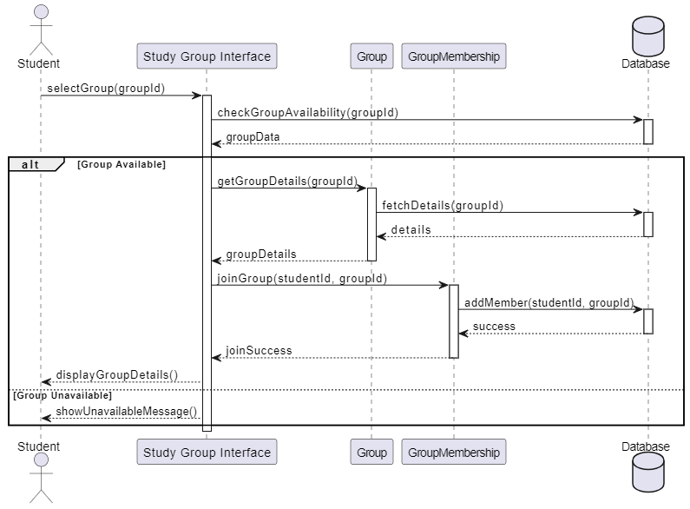

# 3.4 SDs for UC-014

## CreateEvent()

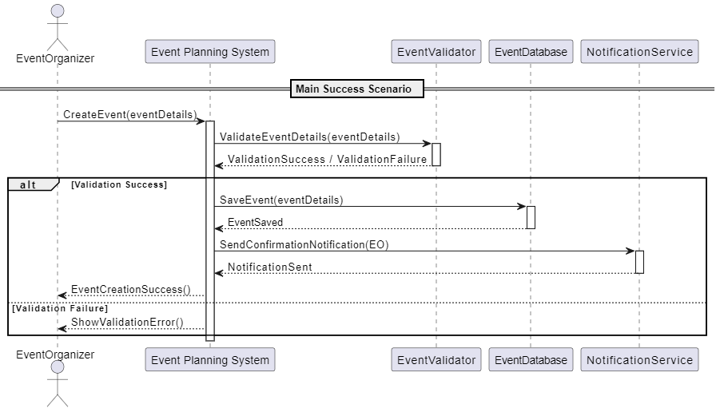

## RequestEventCancellation()

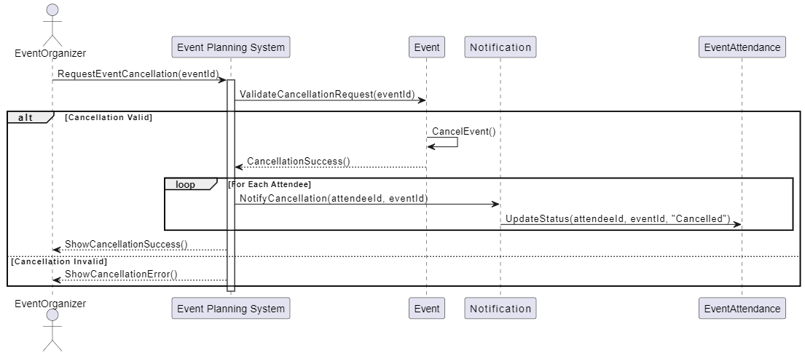

# 3.5 SDs for UC-015

## AccessCourseContent()

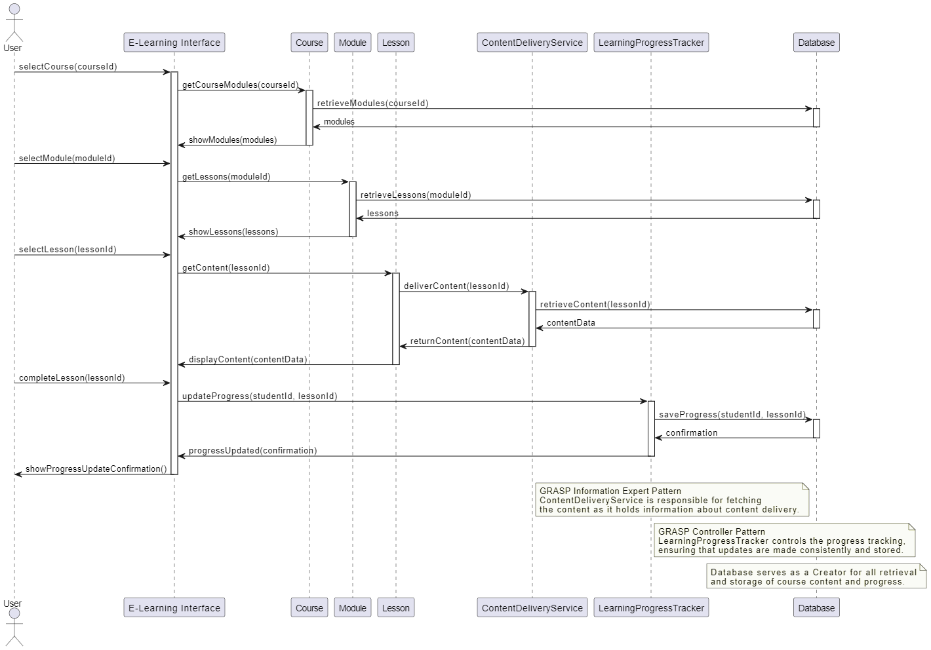

## SelectServiceType()

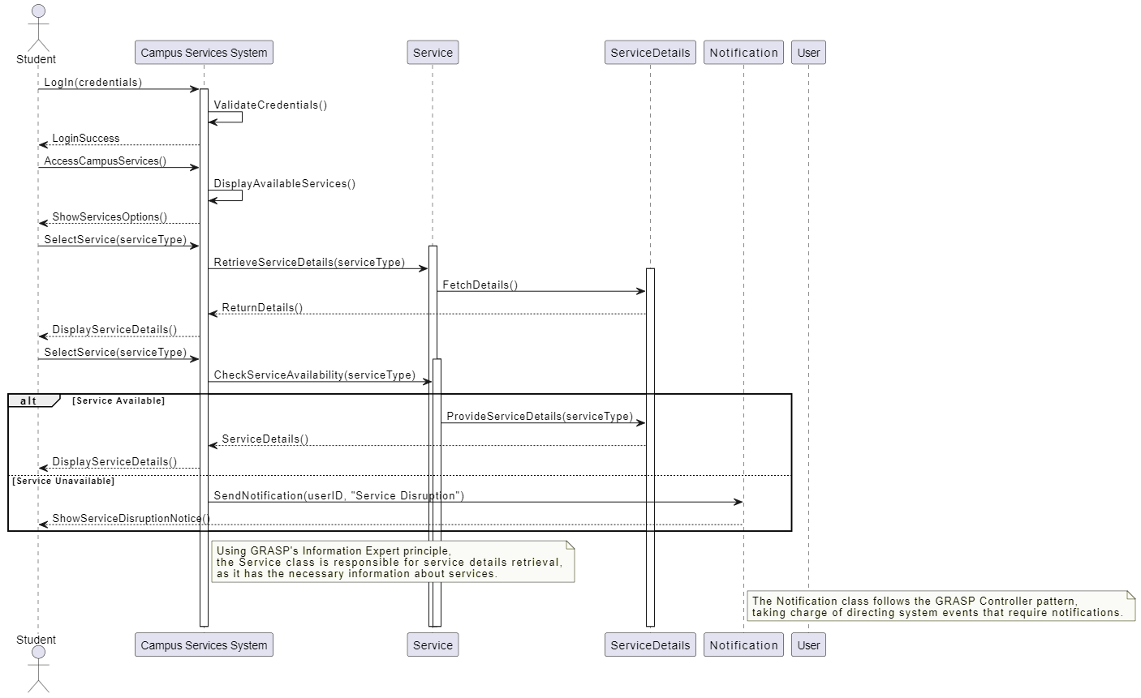

# 3.6 SDs for UC-002

## LikePost()

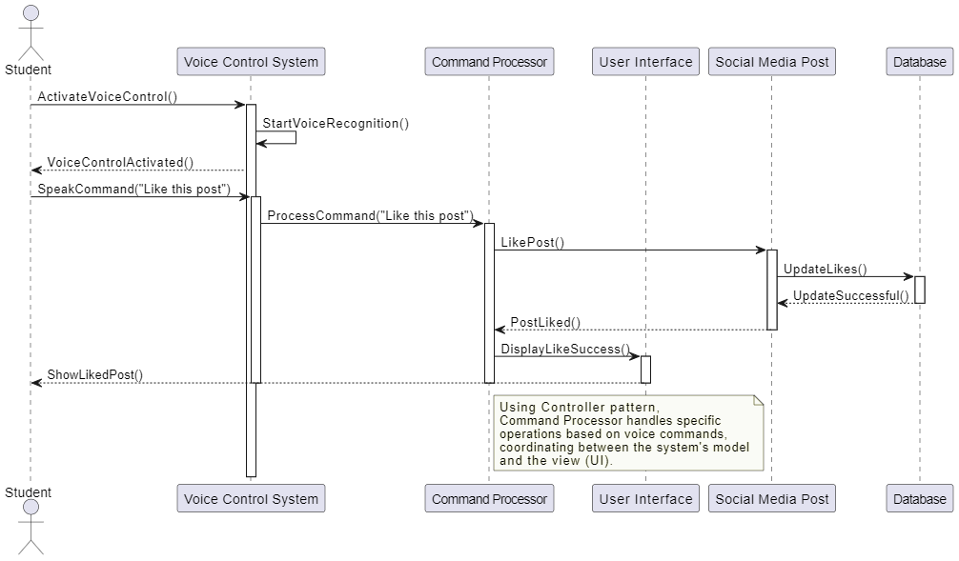

## NavigateToEvents()

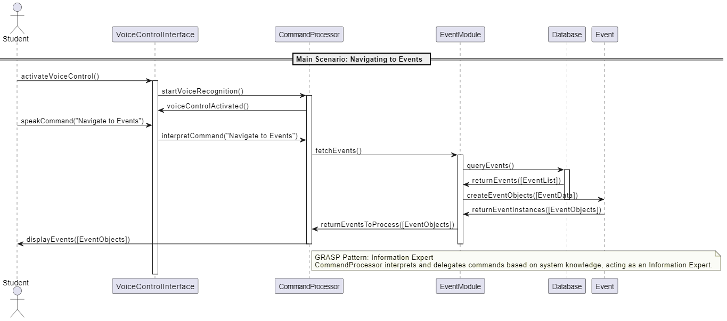

# 3.7 SDs for UC-010

## EnrollInCourseAndAccess()

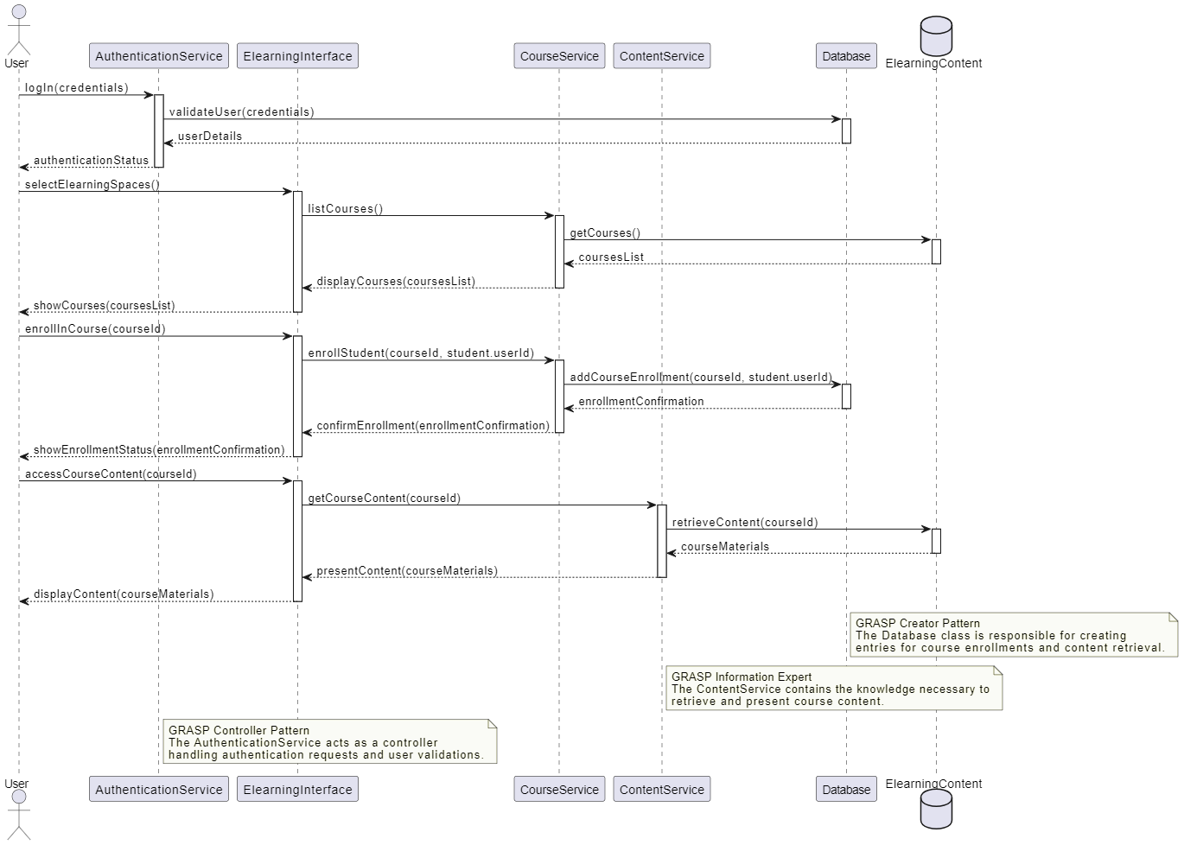

## SelectElearningSpaces()

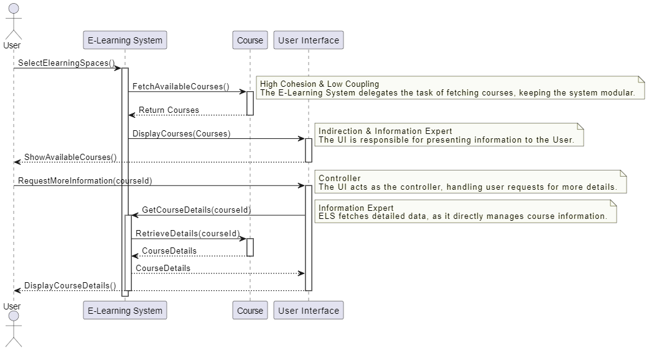

# 3.8 SD for UC-003

## MonitorAndProvideSupport()

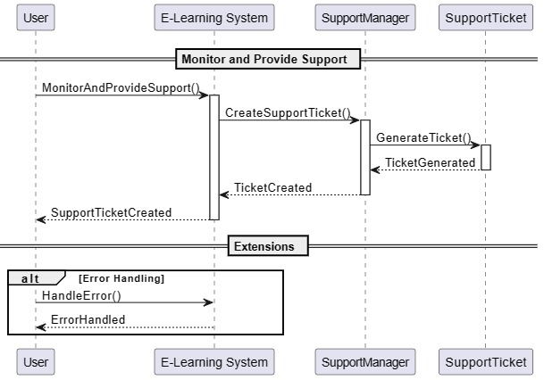

## 3.9 SDs for UC-023

## signUpForWorkshop()

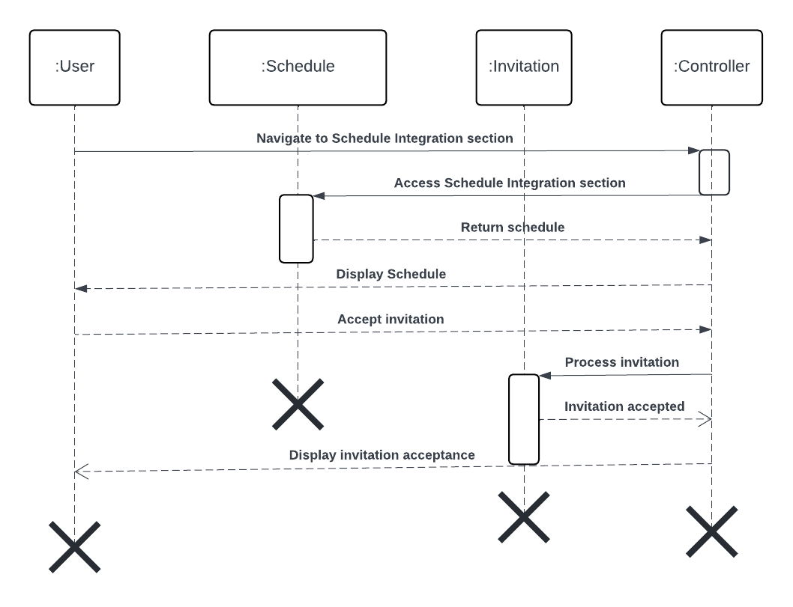

# 3.10 SDs for UC-024

## setDeadlineReminder()

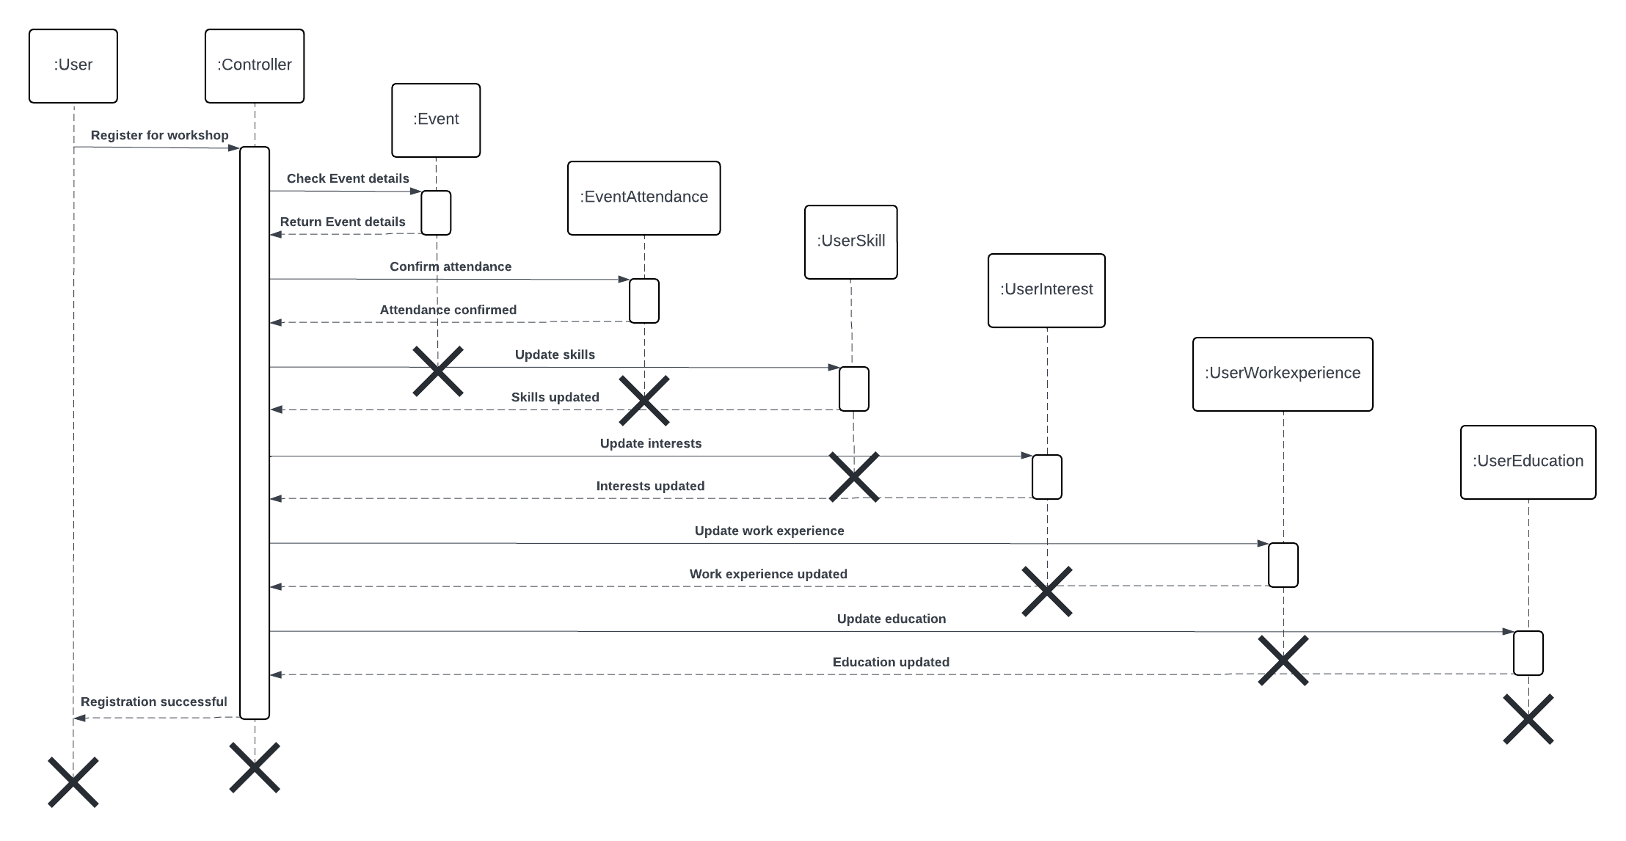

# 3.11 SDs for UC-021

## sendReminder()

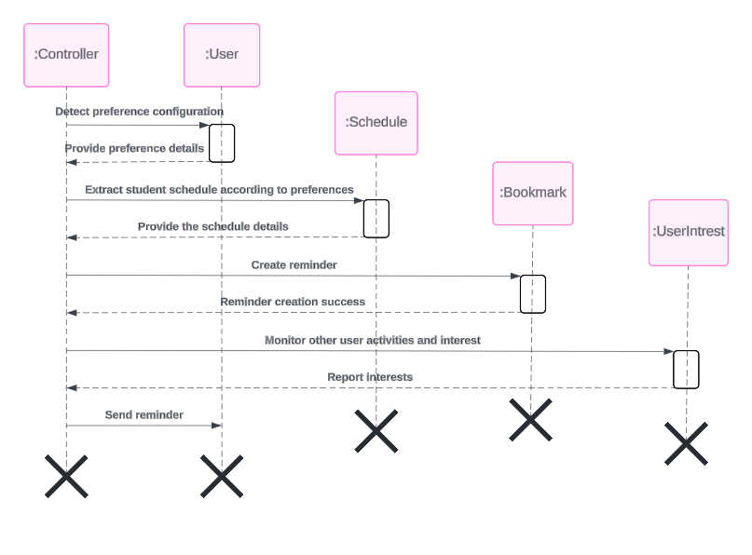

# 3.12 SDs for UC-023

## registerWorkshop()

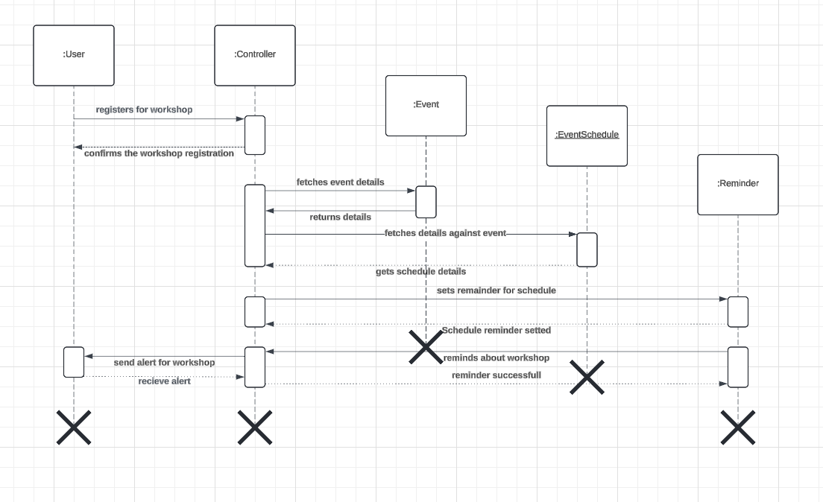

## provideWorkshopDetails()

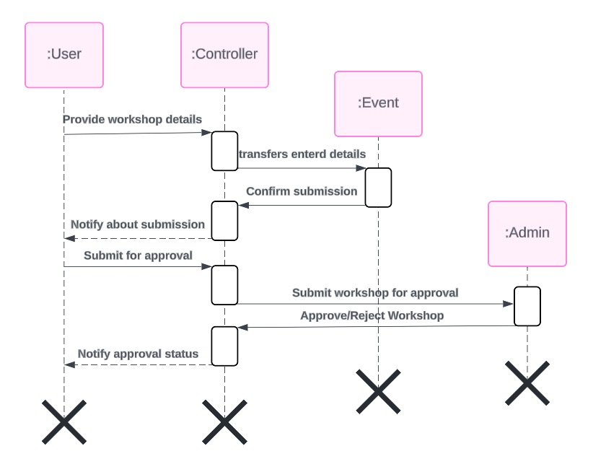

# 3.13 SDs for UC-018

## seekAssistance()

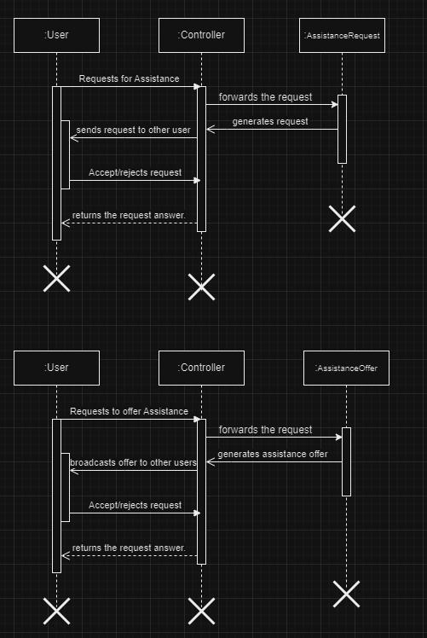

## validateRequest()

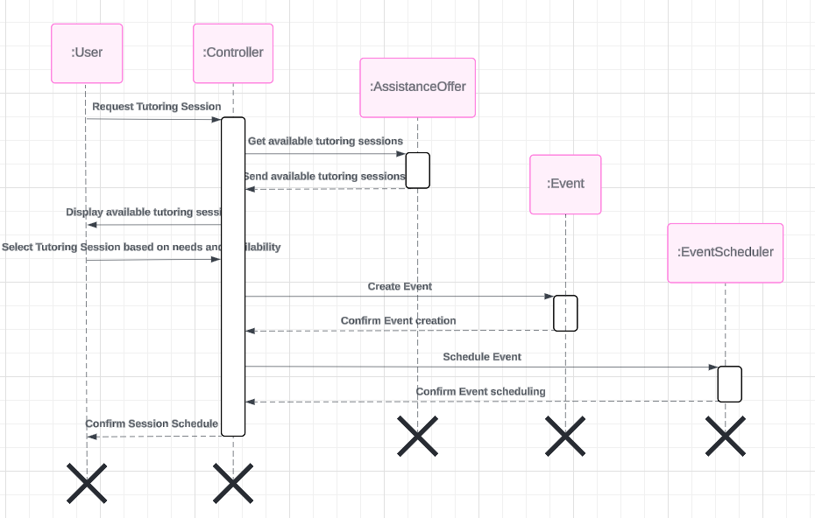

## ScheduleSession()

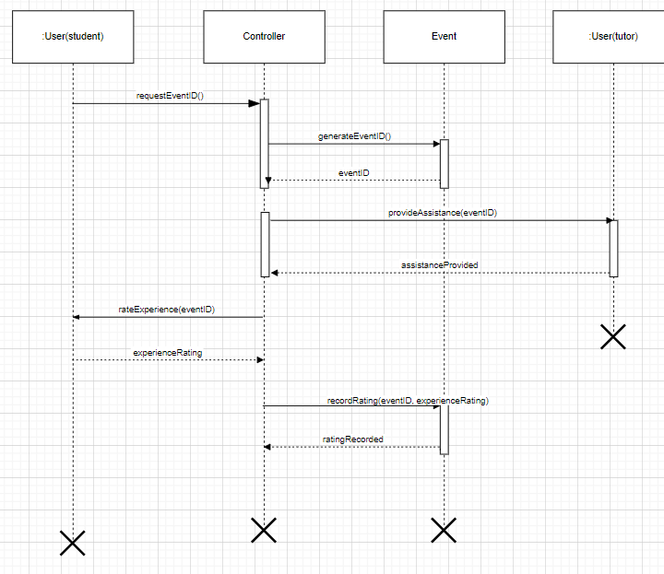

# 3.14 SDs for UC-019

## provideGuidanceAndSupport()

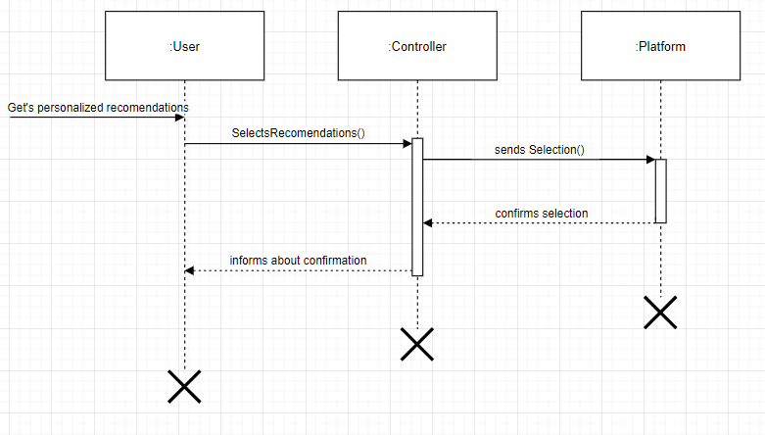

## accessAdvisingSectionn()

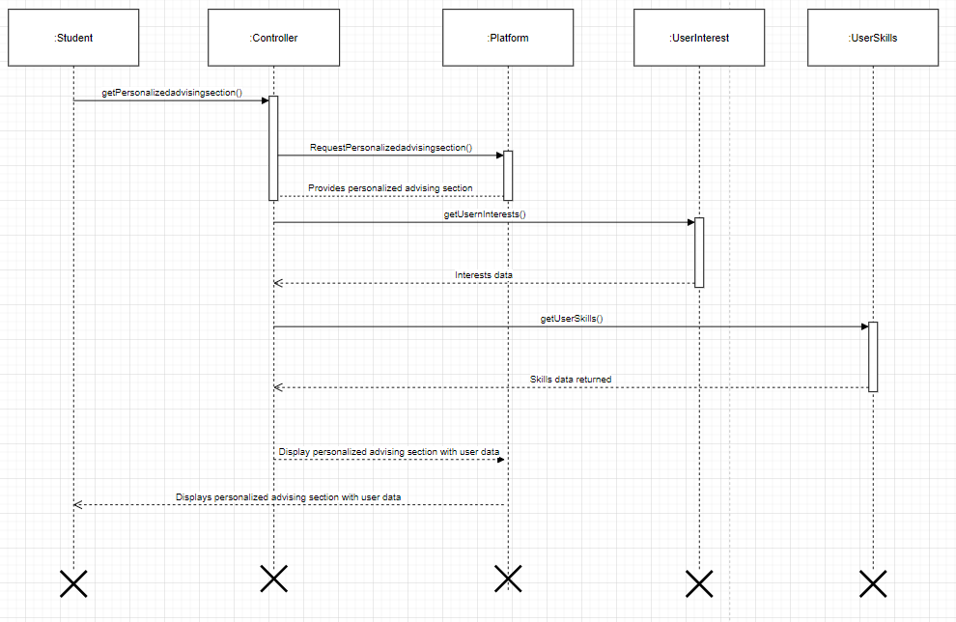

## GenerateAndSelectRecommendations()

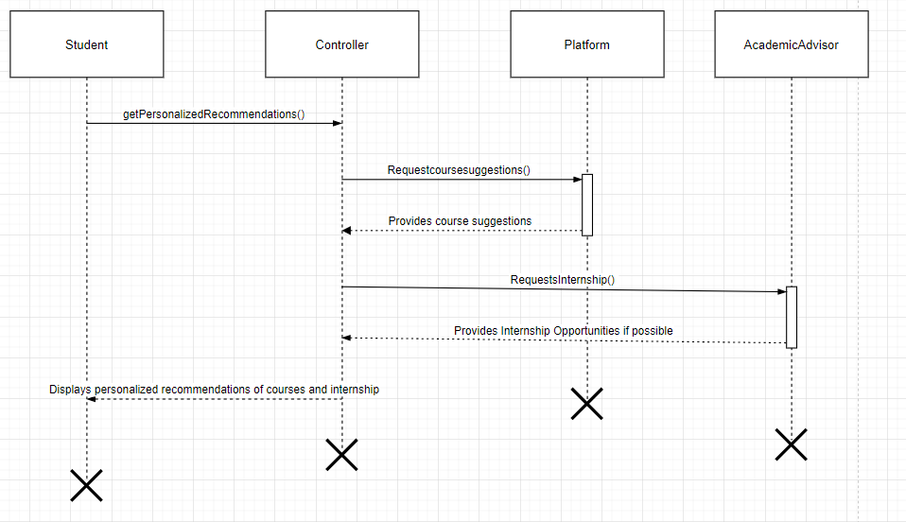

# 3.15 SDs for UC-030

## accessPersonalAcademicAndCareer()

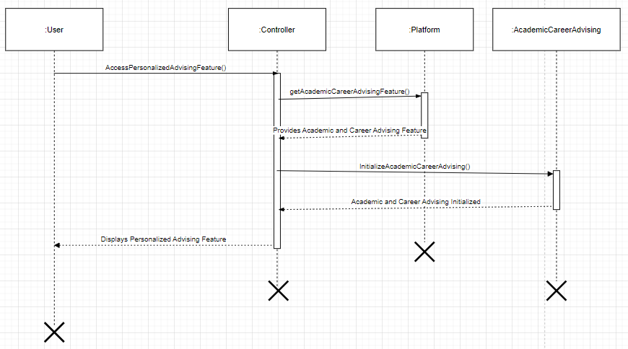

## ProvideAcademicAndCareerInfo()

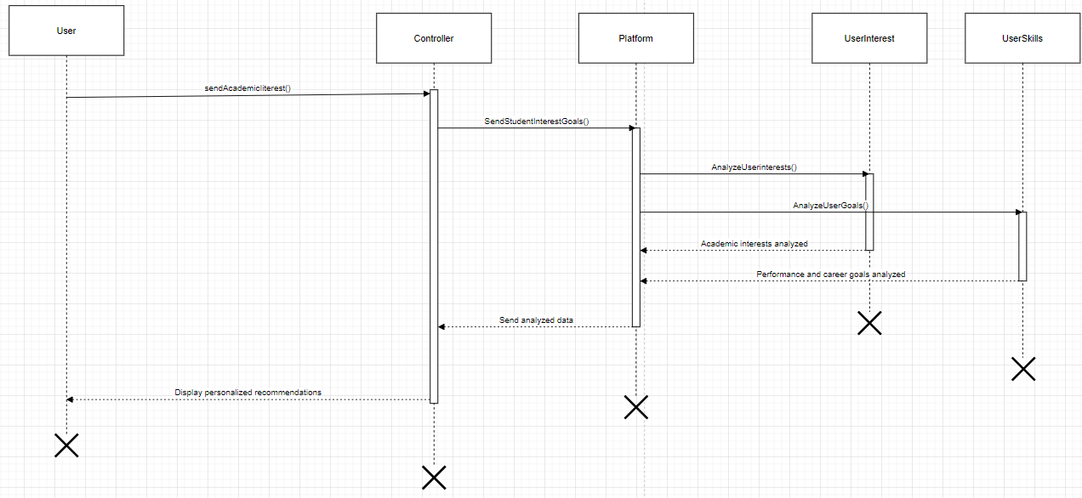

# 3.16 SDs for UC-041

## displayProgress()

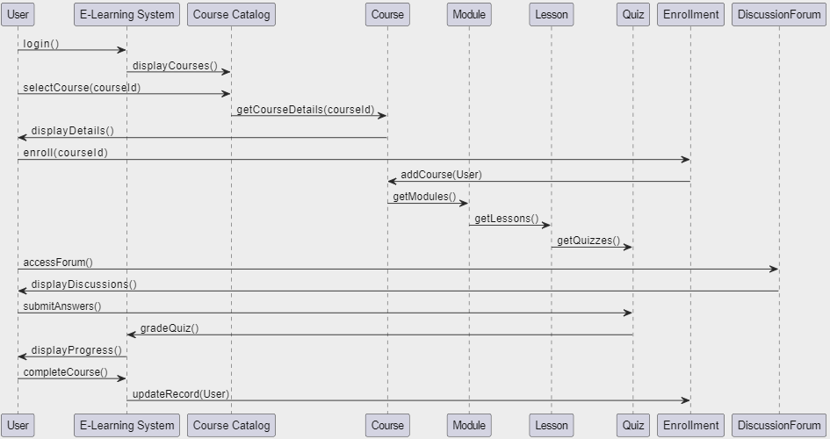

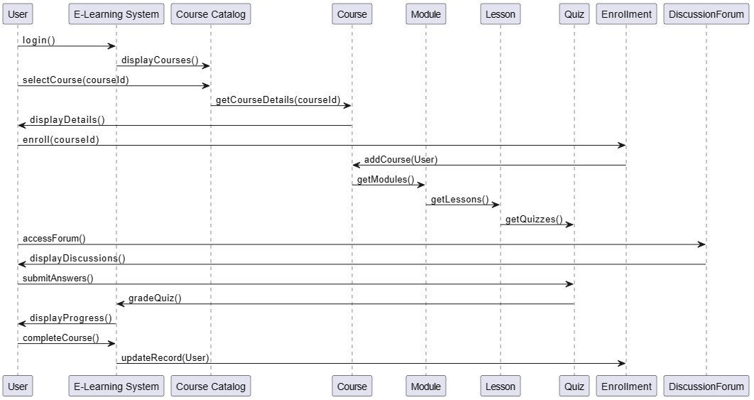

GRASP Pattern Used:

* The controller pattern is used here, with the 'E-Learning System' acting as a controller to coordinate the sequence of actions.
* The 'Course Catalog' acts as a creator as it creates or finds instances of 'Course'.
* 'Enrollment' is applying the information expert pattern, handling the enrollment details of the user.
* The 'DiscussionForum' serves as an interface to the discussion functionality, demonstrating the pure fabrication pattern if it does not represent a real-world entity.

# 3.16 SDs for UC-008

## createStudyGroup()

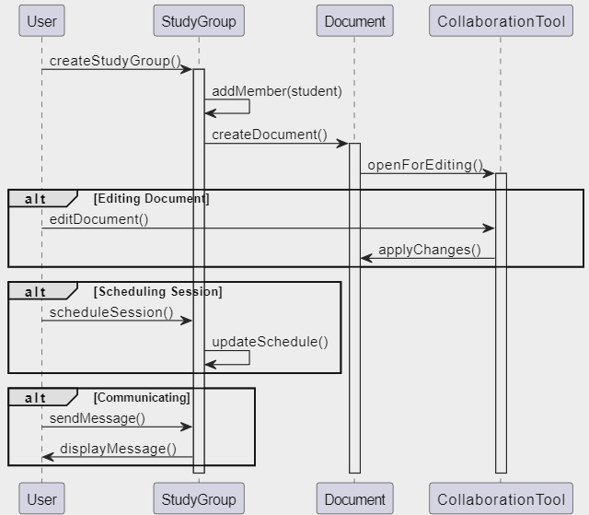

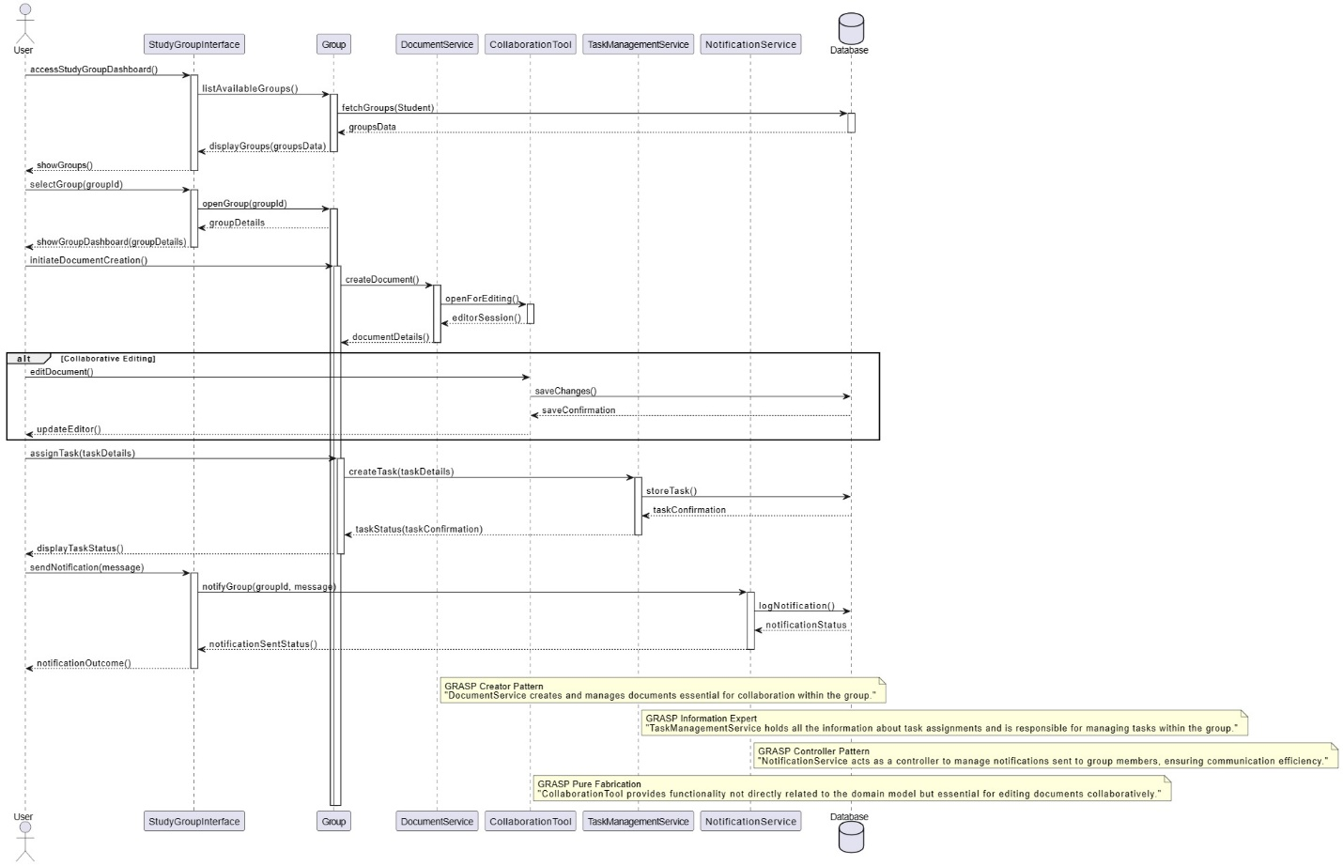

GRASP Pattern Used:

* For the creation of a study group (createStudyGroup()), we are following the Creator pattern because the User is closely related to the StudyGroup and directly contains the operation to create it.
* When editing a document via a CollaborationTool (editDocument()), we use the Controller pattern where the CollaborationTool acts as the controller, handling the request and delegating work.
* For scheduling a session (scheduleSession()), it follows the Information Expert pattern since the StudyGroup has the necessary information about its sessions and members.

# 3.17 SDs for UC-037

## purchaseFromMarket()

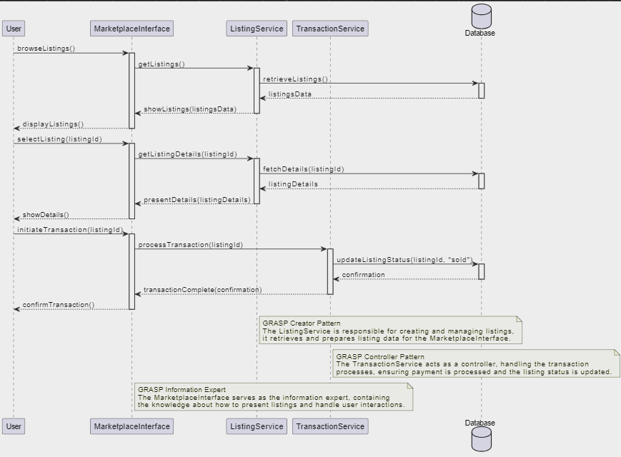

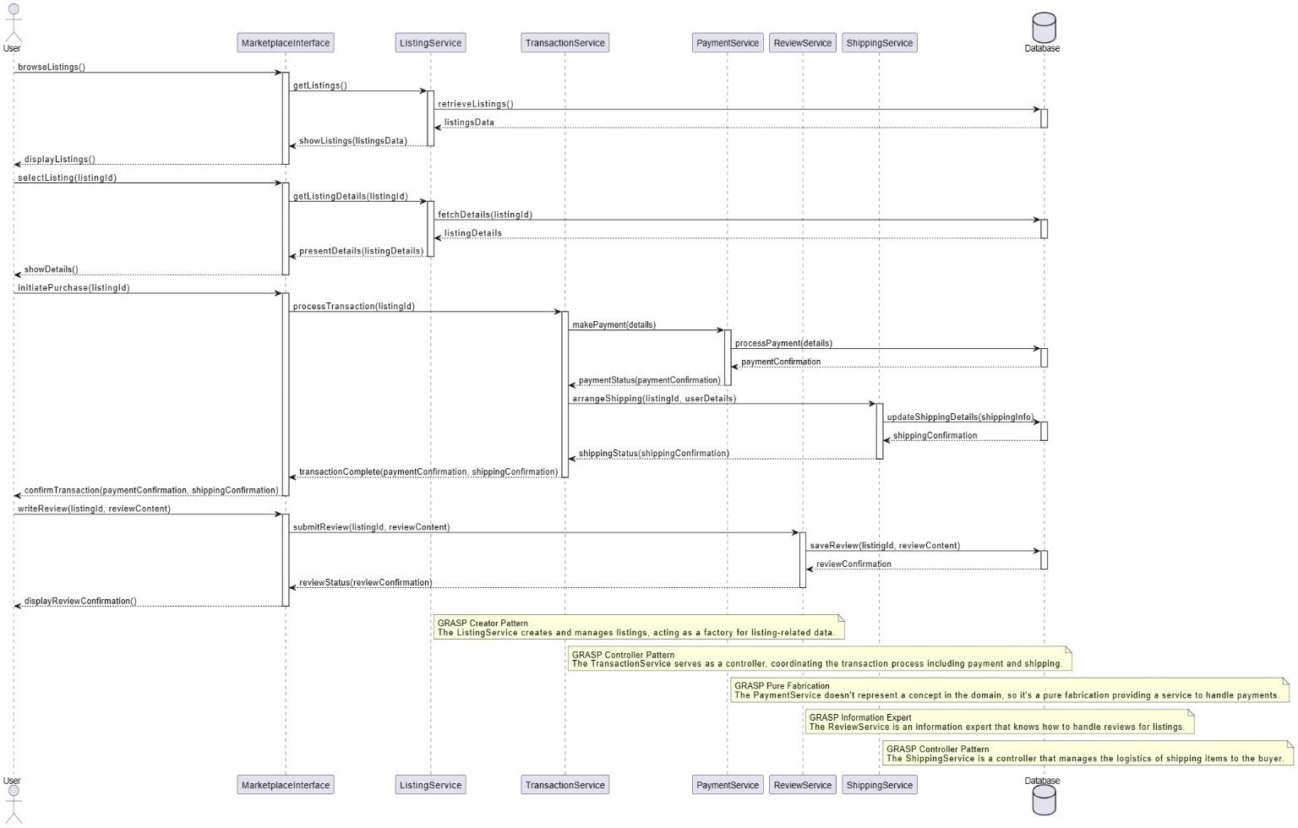

GRASP Pattern Used:

* The ListingService follows the GRASP Creator pattern because it's responsible for creating and managing listings within the system.
* The TransactionService uses the GRASP Controller pattern to encapsulate the logic of coordinating the transaction process.
* The MarketplaceInterface employs the GRASP Information Expert pattern to present information to the user and handle user requests based on its knowledge of the data it is presenting.

# 3.18 SDs for UC-034

## createEvent()

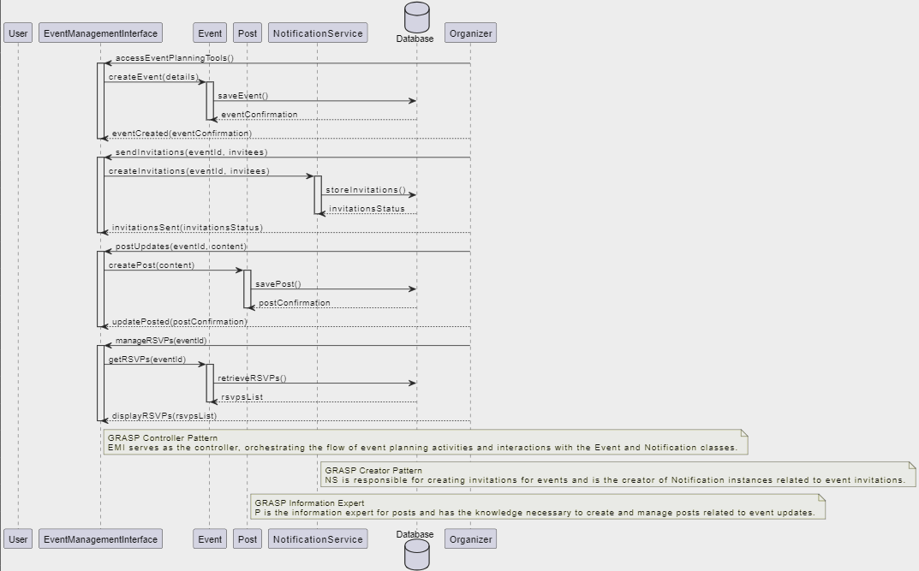

GRASP Controller Pattern: EMI serves as the controller, orchestrating the flow of event planning activities and interactions with the Event and Notification classes.

GRASP Creator Pattern is responsible for creating invitations for events and is the creator of Notification instances related to event invitations.

GRASP Information Expert is the information expert for posts and has the knowledge necessary to create and manage posts related to event updates.

# 4 Class Diagram

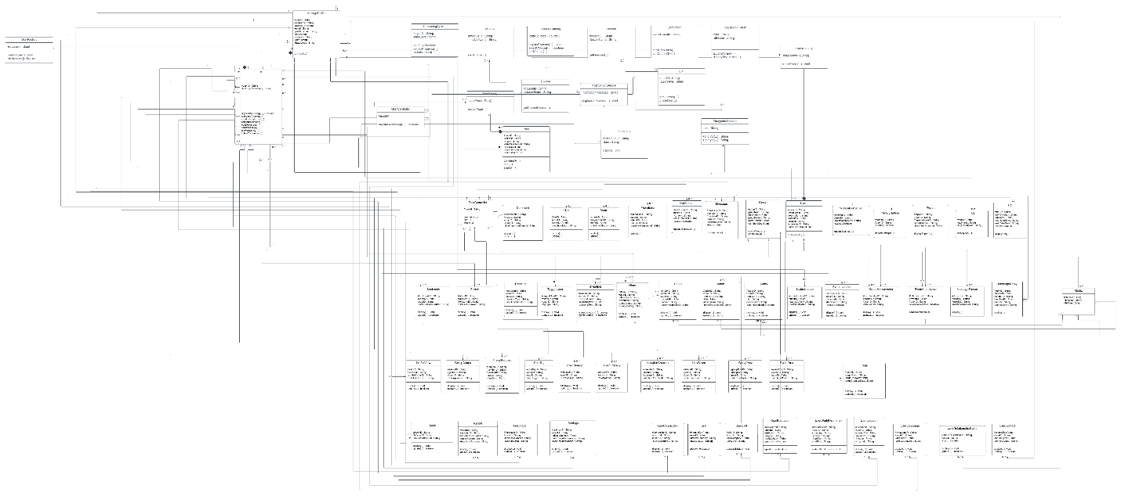

1. ManageProfile class was introduced to cater high coupling and low cohesion in User class. This resulted in low coupling and high cohesion. It also acts as a controller class.
2. UserFactory class was introduced keeping in mind the Creator Pattern of GRASP. This class is the creator of User class.
3. PostFactory class was introduced keeping in mind the Creator Pattern of GRASP. This class is the creator of Post class.
4. NotificationService class was introduced keeping in mind Controller Class and Pure fabrication aspect of GRASP.
5. User, Post, Message, Event, Group classes are responsible for respectively related actions focusing on Information Expert of GRASP.
6. PostController class was introduced as Controller Class for Post.
7. EncryptionService class was introduced to encrypt messages of users to enhance security and are an example of Pure Fabrication.
8. Media class is an interface class which allows classes Photo, Video and Audio to inherit common attributes and functionalities.

# [Class Diagram: Lucidchart](https://lucid.app/lucidchart/f11783ef-df30-4ed6-adbb-f78bc5144de1/edit?page=0_0&invitationId=inv_f52a5ed8-f2f7-449f-bda3-89c3ba9b32ac)

# 5 Domain Model

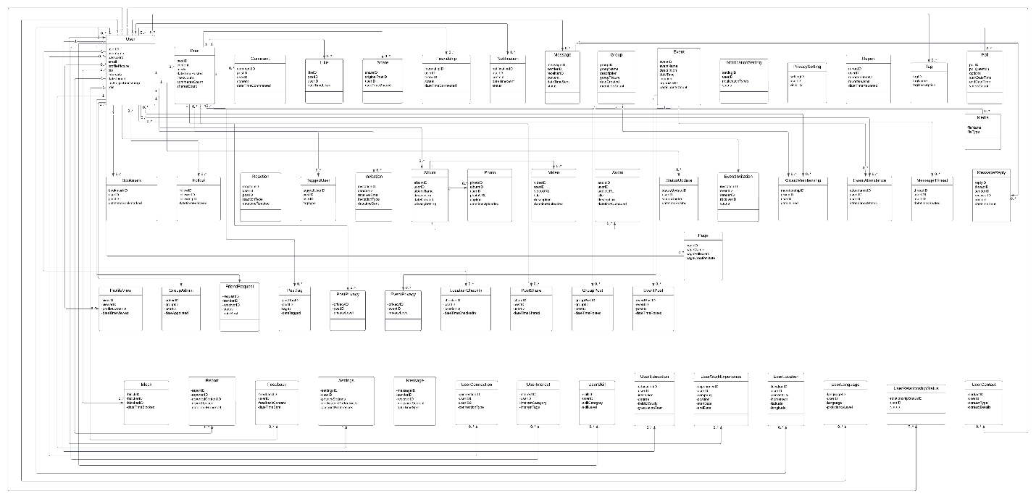

# 6 Work Division

* **Waqas:**

1. Class Diagram
2. 13 System Sequence Diagrams (2.15 – 2.27)

* **Abdul Raffay:**

1. 7 System Sequence Diagrams (2.1-2.7)

* **Kaif:**

1. 7 System Sequence Diagrams (2.8-2.14)

SDs from SSDs divided equally among all.